

NAAN MUDHALAVAN

ServiceNow Administrator Project

**SLA MANAGEMENT FOR HARDWARE GROUP -PRIORITY 4**

**Name : ARATHI V**

**Register No : 723621104004**

**Year : IV**

**Semester : 07**

**SLA MANAGEMENT FOR HARDWARE GROUP -PRIORITY 4**

**ABSTRACT:**

**User Story:-**

**As a Service Desk Agent, I want to ensure that the SLA clock for priority 4 hardware-related tickets pauses when the ticket status is set to "On Hold" and stops when the ticket status is set to "Resolved" or "Closed", so that the SLA accurately reflects the time spent actively working on the ticket and does not include periods when the ticket is pending or completed.**

**Pre-Requisites:-**

1. Knowledge on Service Now.

2. Knowledge on SLA(Service Level Agreement).

**Skills used to solve the problem statement:-**

1. SLA(Service Level Agreement).

2.Service Now Administration.

**Two Major Method :**

Implementation

Result

**Implementation:**

**Activity-1**

1. Open service now developer Instance
2. Click on All
3. Search for SLA Definition
4. Create New
5. Fill the information as mentioned below  
    Name : Hardware Group - Priority 4  
    Type : SLA  
    Target : Response

Table : incident  
 Duration : 1 hour

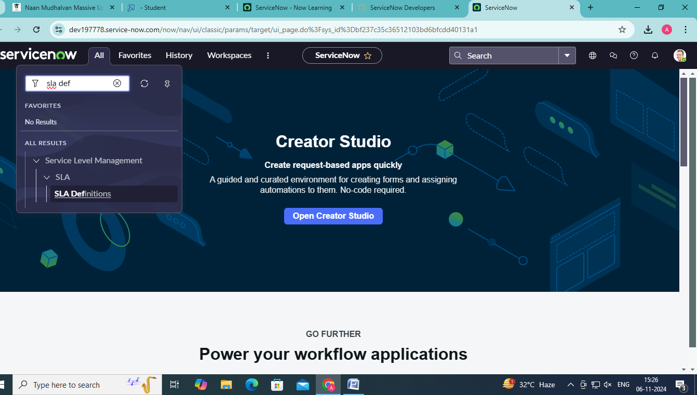

Schedule source : No schedule  
 Leave the other things default

1. Under start condition fill the given information  
   Active>>is>>true  
   Priority>>is>>4-low
2. State>>is>>New
3. Under when to cancel choose
4. When start condition is not me
5. Under stop condition  
   Assignment group >> is not empty
6. .Click on submit

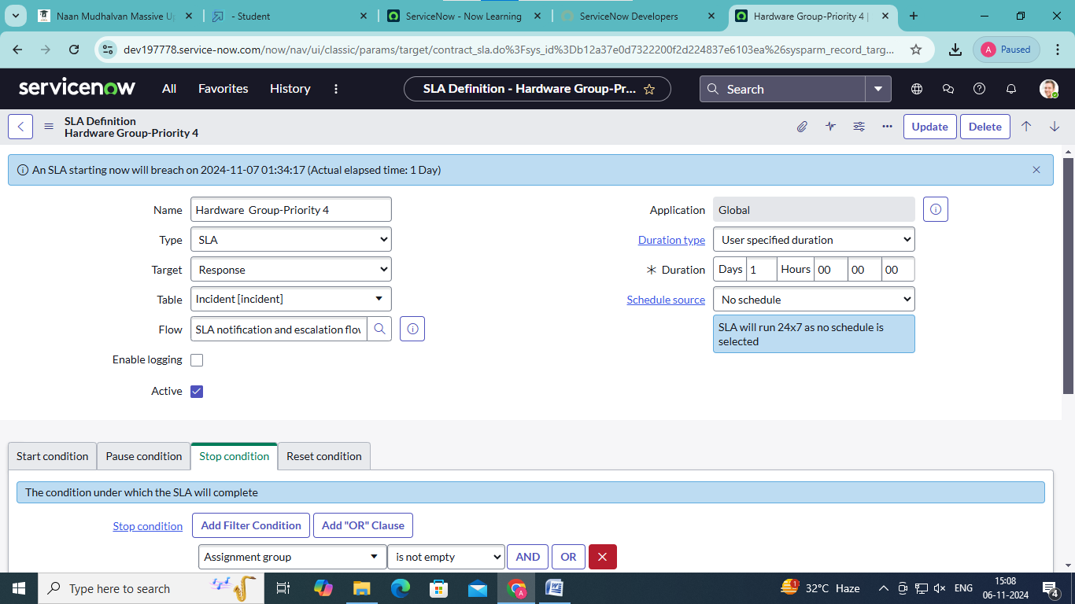

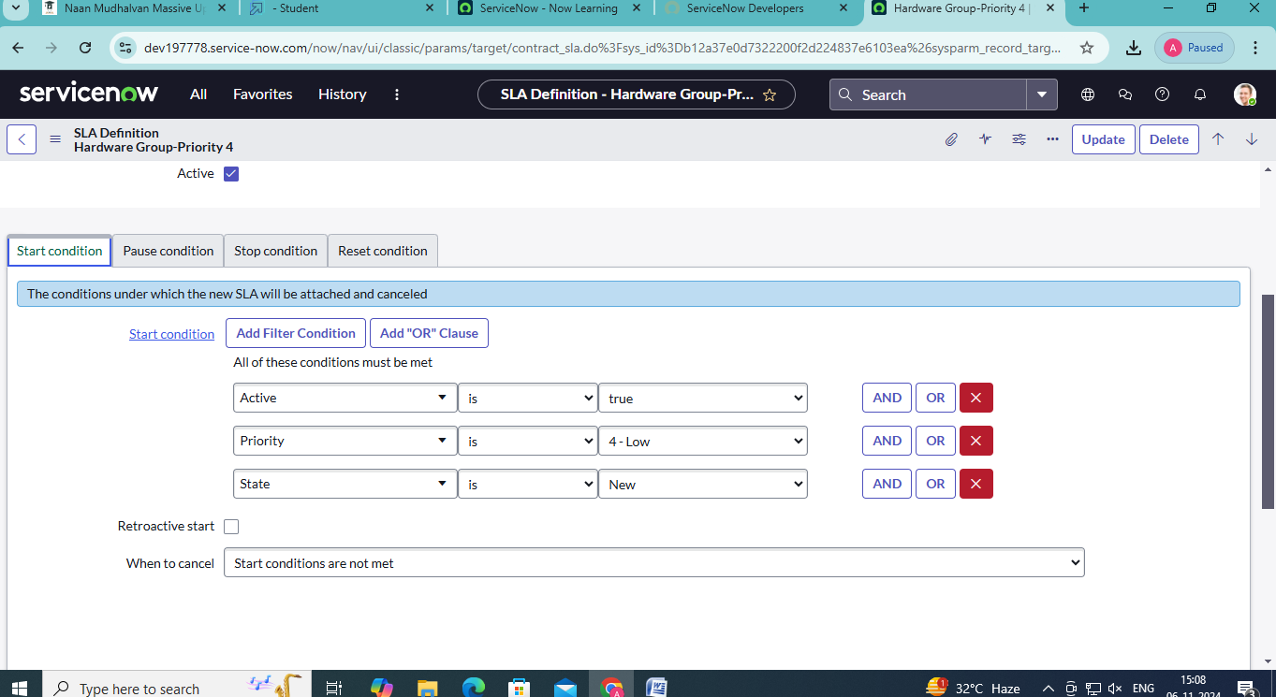

**Activity - 2:**

1. Click on All
2. Search for SLA Definition

3.Create New

4.Fill the information as mentioned below

Name : Hardware Group-Resolution  
Type : SLA  
Target : Resolution  
Table : incident  
Duration : 16 hour

Schedule source : No schedule  
Leave the other things default

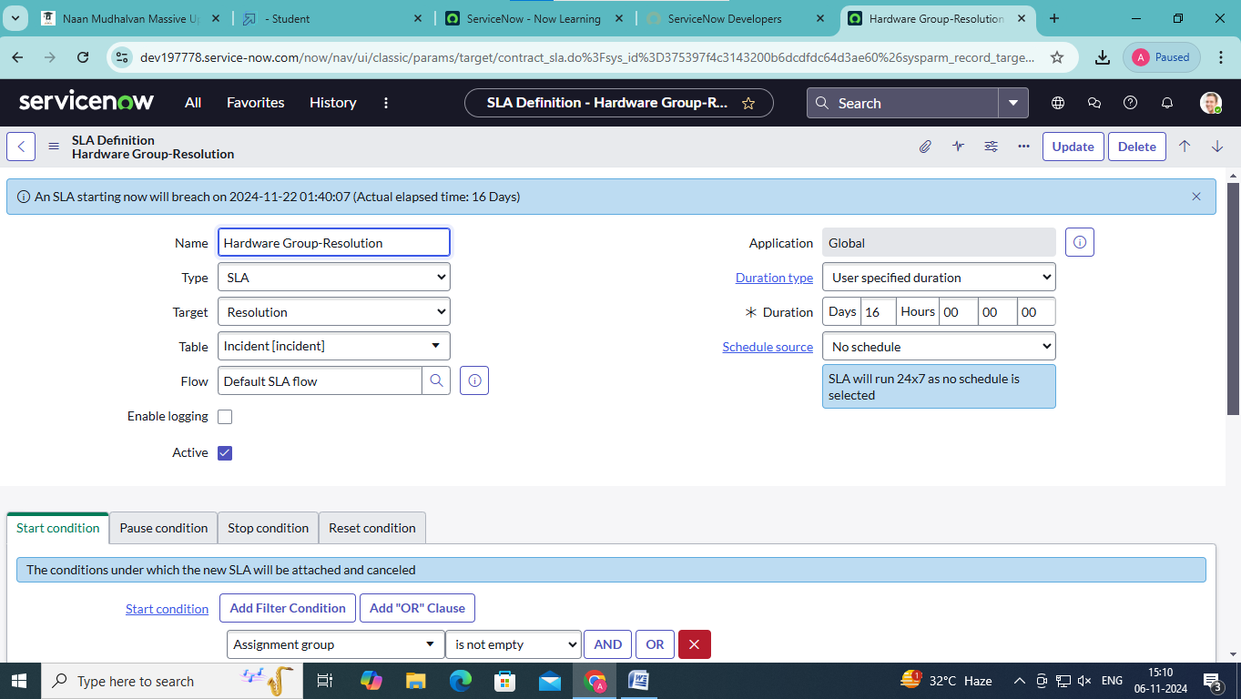

5.Under start condition fill the given information

Assignment group >> is not empty

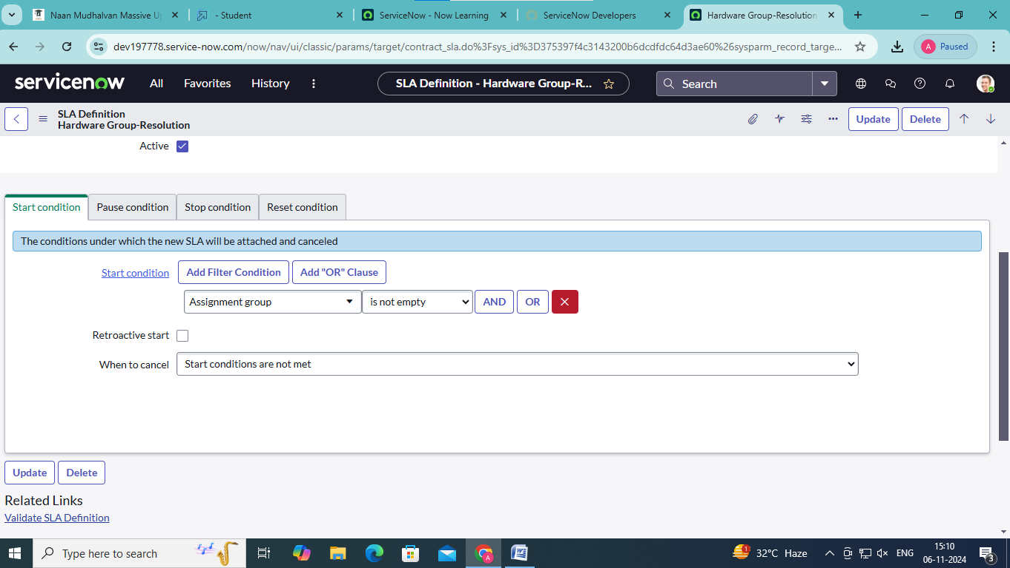

1. Under pause condition fill the following information  
   state>>is>>onhold
2. Under when to resume choose  
   When pause conditions are not met

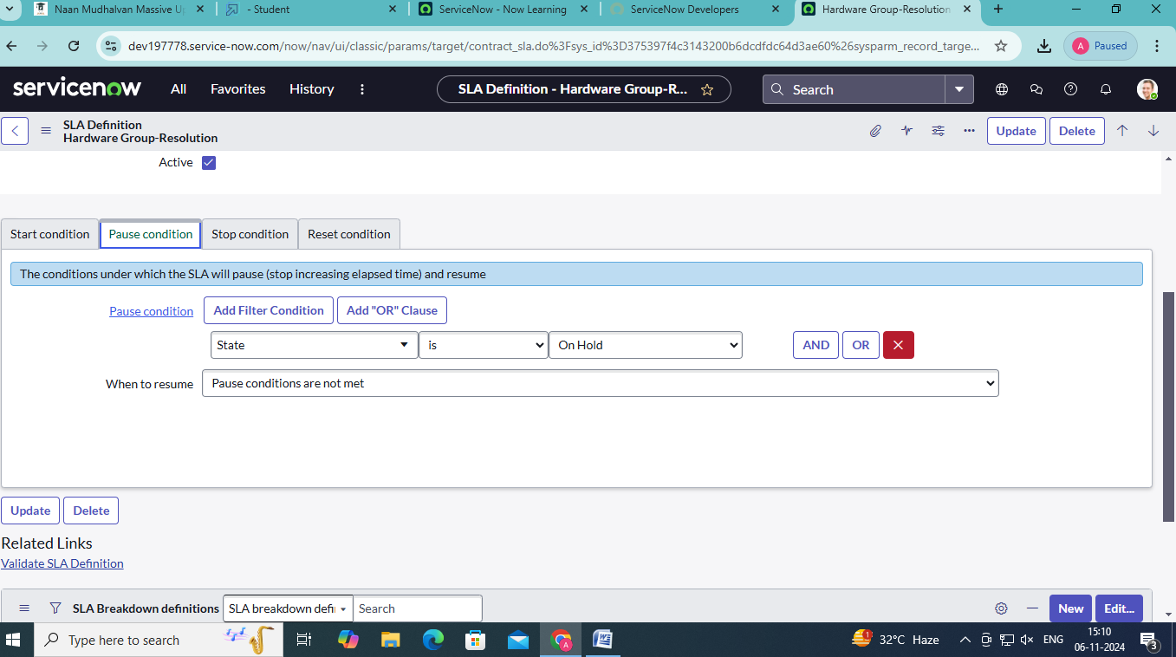

8.Under stop condition fill the following information  
State>>is one of>>resolved,closed

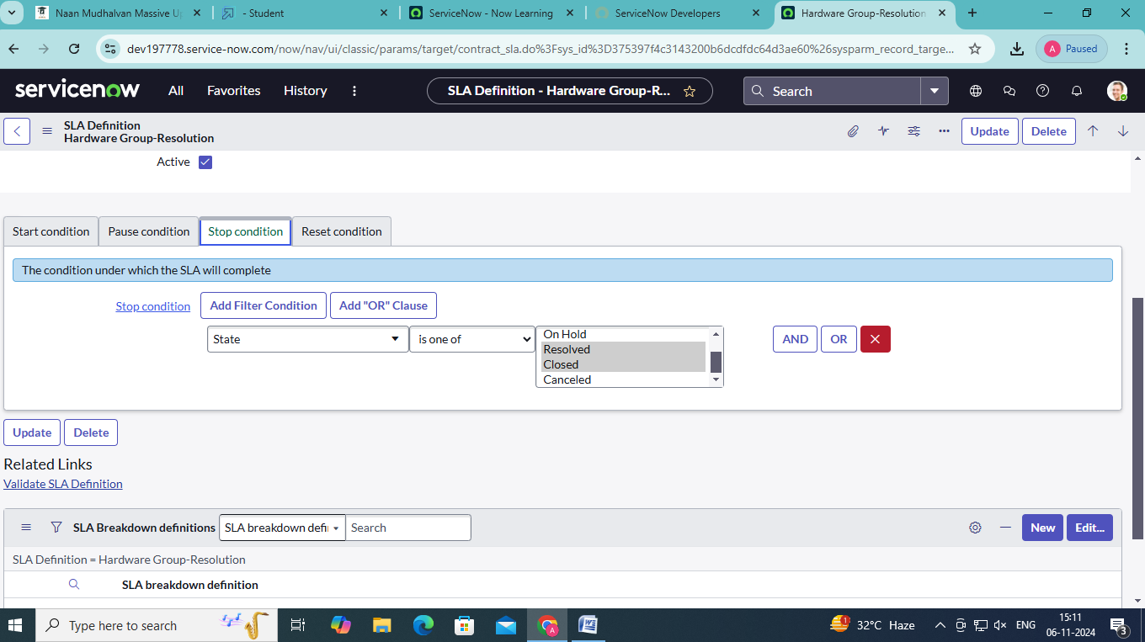

9.Click on submit.

**Result**

1. Navigate to ALL
2. Search for incident
3. Click on create new
4. Fill the incident form and click on save
5. Scroll down under SLA you will find SLA response.
6. Now under assignment group give hardware and click on save.
7. Under sla you will find SLA response should completed and SLA resolution will start.
8. If we change state to resolve you will observe resolution to complete

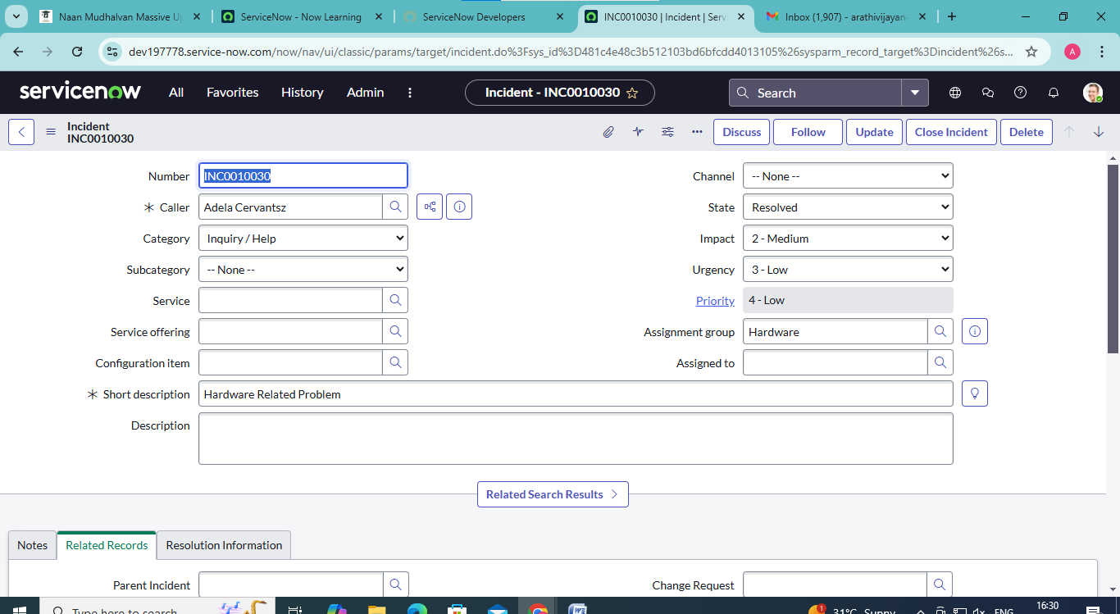

1. You will observe resolution state is in completed

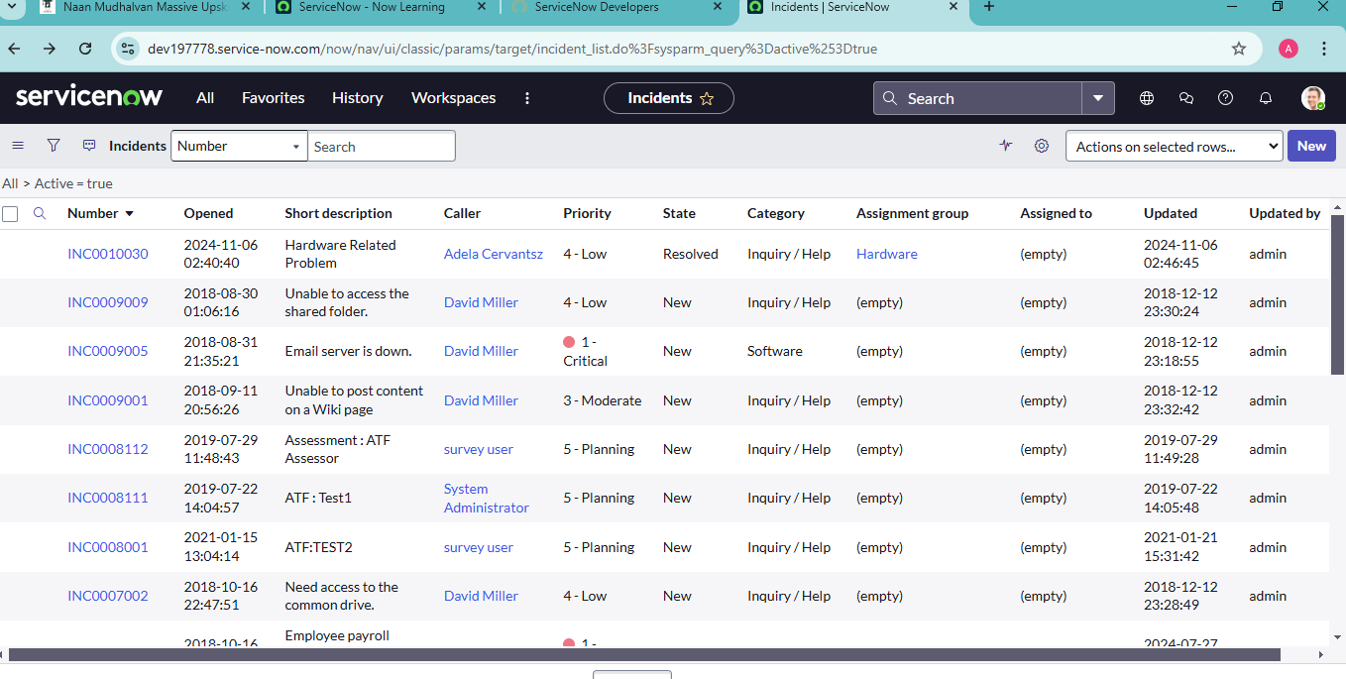

**Conclusion:**

**To implement and manage an SLA in ServiceNow for hardware-related incidents categorized as Priority 4 firstly we created SLA Definition create new and set the procedure ,pausing the SLA when the incident is on hold, and stopping the SLA when the incident is resolved or closed.**

**Set expectations for when a technician will first respond to the issue and when the hardware will be fully resolved or escalated and we will use “Hardware Group Priority-4” and “Hardware Group Resolution”**

**Finally the result category we would implement incident and the procedure was “INC0010030” the Caller is “Adela Cervantsz” and the Response and Resolution was Completed**

**By clearly defining the SLA terms for Priority 4 hardware issues, the organization can effectively manage expectations, reduce downtime, and maintain operational efficiency while not overburdening the support system with lower-priority tasks.**